|  |
| --- |
| Crafty Cuts Laser |
| Final system specifications |
| Version 1.1 |
|  |

|  |
| --- |
| Jack  2-4-2016 |

Contents

Introduction 4

FDD 4

ERD 5

Functions 5

Customer Login – Function 5.0 6

Customer Logout- Function 5.2 7

Customer Reset Password- Function 6.0 7

Customer register – Function 4.0 7

Admin login – Function 7.0 7

Admin login – Function 7.5 7

Customer Update Profile – Function 5.1.1 7

Customer Change Password – Function 5.1.3 7

Admin Update Profile – Function 7.2 8

Admin Change Password – Function 7.7 8

Manage Customers – Function 7.3 8

Add new customer- Function - 7.3.1 8

Delete customer. – Function 7.3.4 8

Manage Items – Function 7.5 8

Add New Product – Function 7.6.1 8

Customer makes inquiry – Function 3.0 8

Customer Forgot Password. -- Function 6.0 9

Update Customer -- Function 7.3.2 9

View item – Function 7.6.2 9

Update item – Function 7.6.3 9

Delete item – Function 7.6.4 9

Admin Forgot Password. -- Function 8.0 10

Customer View Purchase History - Function 5.1.3 10

Admin manage Sales - Function 7.1 10

Admin view order- Function 7.1.1 10

Admin retrieve sales report - Function 7.1.2 10

Admin view inquiries - Function 7.4 10

Admin reply to inquiries - Function 7.4.1 10

Admin retrieve items report - Function 7.6.5 11

User view Similar Products – Function 9.0 11

Admin Manage FAQ – Function 10.0 11

User view FAQ’s – Function 10.1 11

User view news – Function 11.0 11

Admin manage news – Function 11.1 11

# Introduction

This document is meant to provide the user with an understanding of the final specifications of the system. Both the FDD and ERD have been provided separately as well as copied for easier readability.

# FDD

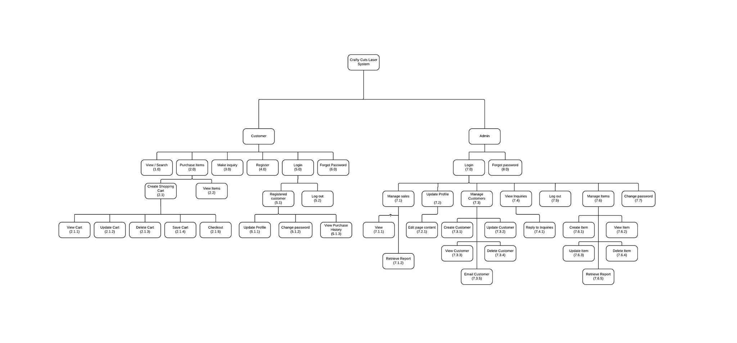

# ERD

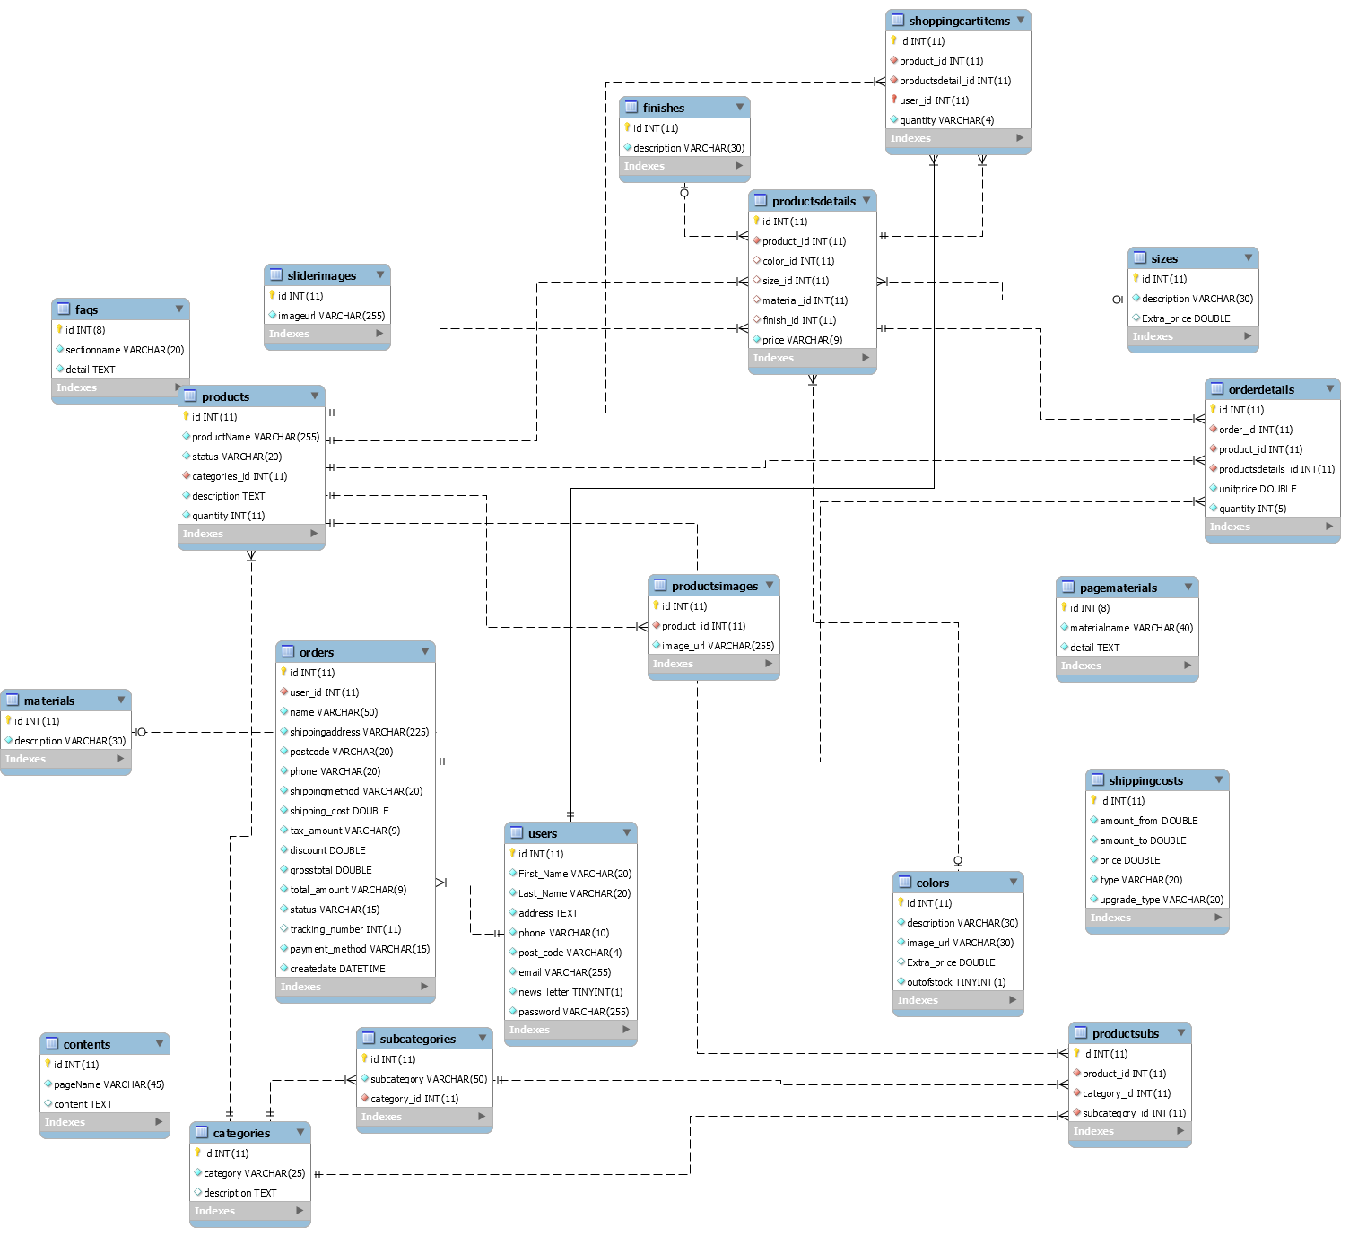

# Functions

|  |  |  |
| --- | --- | --- |
| Delivery cycle | Tasks | Delivery Date |
| Delivery Cycle 1 | * (4.0) Customer register. * (5.0) Customer login. * (5.2) Customer logout. * (6.0) Customer forgot password. * (7.0) Admin login. * (7.5) Admin logout. * (8.0) Admin forgot password. | **23-Sep-2015** |
| Delivery Cycle 2 | * (5.1.1) Customer update profile. * (5.1.2) Customer Change Password. * (7.2) Admin update profile. * (7.3.1) Add new customer. * (7.3.4) Delete customer. * (7.6.1) Create item. * (7.7) Admin Change Password. | **21-Oct-2015** |
| Delivery Cycle 3 | * (3.0) Customer makes inquiry. * (6.0) Customer Forgot Password. * (7.3.2) Update Customer. * (7.6.2) View item. * (7.6.3) Update Item. * (7.6.4) Delete item. * (8.0) Admin Forgot Password. | **30-Nov-2015** |
| Delivery Cycle 4 | * (5.1.3) Customer view purchase history. * (7.1) Manage sales. * (7.1.1) View sale. * (7.1.2) Retrieve sales report. * (7.4) Admin view inquiries. * (7.4.1) Reply to inquiries. * (7.6.5) Retrieve items report. | **10-Dec-2015** |
| Delivery Cycle 5 | * (9.0 ) User view similar products * (10.0) Admin Manage FAQ’s * (10.1) User view FAQ’s * (11.0) User view news * (11.1) Admin manage news | **19-Jan-2015** |

## Customer Login – Function 5.0

The customer login function will take a username and password. This will require a valid email address and password. In the event of incorrect login credentials an error message will be displayed prompting the user to try again.

Customers wanting to log in will be prompted for their login credentials. Once credentials have been inputted the customer will click “Login”. If the correct credentials are inputted then the customer will be brought to the home screen welcomed:

There is also a link under the Login form, if the user forgot his/her password, he/she can reset a password by click that link.

In the event of incorrect login credentials, the customer will be presented with an error message and then prompted to try logging in again with the correct credentials.

## Customer Logout- Function 5.2

In the home page, a logged in user can log out by click the link in the top right.

## Customer Reset Password- Function 6.0

Similarly to how customers register, they will be prompted to fill out a form. Through this form they are also required to provide some credentials, such as name, email address and if applicable a previous password they can remember.

## Customer register – Function 4.0

Customers are prompted to fill out a form which asks for their Email (Username) password and personal details. Customers are required to fill in everything that has a red asterisk. The rules for each box is in light grey writing.

## Admin login – Function 7.0

An admin wanting to log in will need to input their credentials into the login fields. This is the same login screen as customers see. nce the Admin inputs their credentials they should click “log in” and will be taken to the home screen.

## Admin login – Function 7.5

The admin logs out just like customers, by pressing the log out link at the top right hand side of the screen. Once clicked it’ll give a confirmation message and redirect the admin to the log in page.

## Customer Update Profile – Function 5.1.1

Once a customer has logged in successfully they are able to update their profile by first clicking on the My Account tab in the top right of the screen and then they can change their profile information by clicking on “Edit my profile” from the menu provided.

Once there, a customer can edit their first name, last name, shipping address and phone number.

## Customer Change Password – Function 5.1.3

Customer is required to be logged in. Then they go to their profile by clicking on “My Account”. From here they are able to click on “Change My Password” and then input a new password as required. They will then confirm their password on more time.  If the passwords do not match an error message will be displayed.  Once successfully changing the password, Customers will be logged out and prompted to log in again. Current password is not required as additional authentication.

## Admin Update Profile – Function 7.2

Admin can update their profiles the same way as Customers.  Once the admin has logged in, they click on “My Account” and then "Edit my profile” from the menu provided.  Once there an admin can change their details exactly like a customer.

## Admin Change Password – Function 7.7

Once logged in the Admin can go to My Account by clicking on the tab in the top right hand side of the screen and then click on Change My Password in the menu. From there the Admin will be required to enter a new password and then confirm it. Current password is not required as additional authentication.  Once successful the Admin will be logged out and prompted to log back in.

## Manage Customers – Function 7.3

### Add new customer- Function - 7.3.1

While logged in the Admin clicks on My Account and goes to Add New Customer. This tab is selected from the menu available to the Admin. Once the Admin has filled out all the necessary details they are able to create a new user.  This form is exactly like the registration form. All fields are expected to be filled out correctly and passwords must be 8 characters or more.

### Delete customer. – Function 7.3.4

While logged in the Admin clicks on My Account and goes to View All Customers. Once there the admin may choose to delete a customer by clicking on delete. No confirmation will be required.

## Manage Items – Function 7.5

### Add New Product – Function 7.6.1

Once the admin is logged in, to add a new product they go to their account by clicking on “My Account” from here they are presented with a menu. Select “Add new product” from here they are taken to the products mage.

Input Product Name and description before submitting. From here the product has been saved. The Admin is presented with a confirmation message “The product has been saved”. From here the admin can add further details to the product by first selecting the product name of the product and then inputting further details.  After successfully inputting the product details the Admin will be presented with a message.

Finally the Admin can upload an image for the product.

### Customer makes inquiry – Function 3.0

From the user's main navigation panel, users can click contact us to make an inquiry. This will bring up a form to allow users write their inquiry. The system will ask for the input of name, email address, subject of the inquiry and the inquiry content. After user fulfilled all the contents, they can click submit to send the inquiry to admin. Admin will receive an email after users submitted the form.

## Customer Forgot Password. -- Function 6.0

From the login page, if a customer has forgotten their password they will need to click on forgot password button under the email field. It will take the customer to a page where he/she needs to enter her/his registered email address. If the entered email is not correct or not registered in the system, then the system will show an error message. If the email is registered then the system will generate random password and send it to the registered email address. From here the customer can log back in with the randomly generated password.

### Update Customer -- Function 7.3.2

From the navigation bar in the my account page, the admin can click the view all customers to check all the customers and when the admin click the edit , they will be able to edit the details of that customer to help them update her/his  personal details( address,post code , etc.). After the admin has done edit, the details of that customer will be update once the admin clicks to submit the form.

## View item – Function 7.6.2

From the account menu, the admin can click on view products. This will bring up a list of all current products. If the admin clicks view it will take them to the product listing, where they can see the product as logged in customer sees it.

From the customer’s perspective, the customer click the store will see all the currently available item and if they click read more , they will be redirect to product details page and they will be able to see the details of that item.

## Update item – Function 7.6.3

Navigating from the Admin options menu the admin will click on view products, then edit product. From here the admin will be presented with a form, to update the product name,status and description. As of build 3, the editing of a product and then the many variations are separated.   
  
Example, product: Apple, may come in 2 sizes and 10 colours. If the admin would like to edit apple they can follow the steps above and edit the name, product status and description. In order to edit the colours and sizing the admin will need to edit each individual listing. This will be improved upon in build 4, so that the variations of a products are grouped together and can be edited all at once.

## Delete item – Function 7.6.4

The admin navigates from their account menu to “List products” from there the admin can click on delete, which will delete the entire product and its variations (colours, sizes etc) from the website. The deletion of a very specific variant is not yet easily support but this too will be improved upon in DC4.

## Admin Forgot Password. -- Function 8.0

From the login page, if the admin has forgotten his/her password, then they will need to click on the forgot password button under the email field. It will take the admin to a page where he/she needs to enter her/his registered email address. If the entered email is not correct or not registered in the system, then the system will show an error message. If the email is registered then the system will generate random password and send it to the registered email address. From here the admin can log back in with the randomly generated password.

## Customer View Purchase History - Function 5.1.3

Once logged in the customer is to navigate to their control panel by clicking on “My Account”. From here the customer will be able to click on the menu item View Purchase History. This will show a report of all their purchases. They may select an item to view it or navigate back through the website.

## Admin manage Sales - Function 7.1

Once logged in the Admin navigates to their control panel by clicking on “My Account”. From here the Admin will be able to select manage sales tab. This will take them to a page with a filled table of all orders and sales.

## Admin view order- Function 7.1.1

Once logged in the Admin navigates to their control panel by clicking on “My Account”. From here the Admin will be able to select manage sales tab. This will take them to a page with a filled table of all orders and sales. From here the admin may select to view an order. Once view is selected the admin will be directed to a page which displays all the order information.

## Admin retrieve sales report - Function 7.1.2

Once logged in the Admin navigates to their control panel by clicking on “My Account”. From here the Admin will be able to select “retrieve sales report”. This will generate a sales report as a PDF and allow them to save it to file, email to themselves or print it.

## Admin view inquiries - Function 7.4

The admin goes to the website url that connects them to the email host. Once there the admin will be prompted to log in with their username and password. The Admin is to use the username and password which is associated to the account they would like to use. In this case it’s the inquiries email or [Hello@craftycutslaser.com](mailto:Hello@craftycutslaser.com). Once logged in the admin will be able to browse their emails as done on any other service.

## Admin reply to inquiries - Function 7.4.1

The admin goes to the website url that connects them to the email host. Once there the admin will be prompted to log in with their username and password. The Admin is to use the username and password which is associated to the account they would like to use. In this case it’s the inquiries email or [Hello@craftycutslaser.com](mailto:Hello@craftycutslaser.com). Once logged in the admin will be able to browse their emails as done on any other service. Once an email has been opened the admin can click reply and type an email response as per usual.

## Admin retrieve items report - Function 7.6.5

Once logged in the Admin navigates to their control panel by clicking on “My Account”. From here the Admin will be able to select “retrieve items report”. This will generate a report as a PDF and allow them to save it to file, email to themselves or print it.

## User view Similar Products – Function 9.0

When a product has been added to the store and assigned a category or sub categories, similar products will be displayed. This is available to any user of the system and is not restricted to members, admins or guests. Similar products are worked off of categories and subcategories.

Similar products only works across subcategories of a product, therefore related products won’t be shown which may logically be associated but not

## Admin Manage FAQ – Function 10.0

The admin is able to edit the FAQ page as any other regular post. If a new section is to be added to the FAQ the admin is able to do this which will pre configure a new section for the FAQ page. From there the admin is able to edit and add new questions as they see fit. There is not set format for the FAQ layout so the admin is free to choose how to structure the page. Only Admins can edit the page however anyone including unregistered guests may view.

## User view FAQ’s – Function 10.1

As mentioned above any user may view the FAQ’s this is inclusive of unregistered guests. By clicking on the FAQ tab in the main menu of the webpage the user can view all the most frequently asked questions that the admin has provided answers for.

## User view news – Function 11.0

The News section of the website is very straight forward, it is a small static section on the right side bar of the website and it displays in dot point form short news updates. These are grabbed from the news page which is handled by the admin. Any user may view the news.

## Admin manage news – Function 11.1

In the admin’s back end they are able to view the news pages. This page is a completely editable page, just like the about us page. If an admin would like to edit the news they must first navigate their control panel and click on edit pages, then news and from there they can edit the news section freely.